**Task 01:**

**Activity_main.xml:**

*<?*xml version="1.0" encoding="utf-8"*?>*<RelativeLayout xmlns:android="http://schemas.android.com/apk/res/android"  
  
 xmlns:tools="http://schemas.android.com/tools"  
 android:layout_width="match_parent"  
 android:layout_height="match_parent"  
 tools:context=".MainActivity">  
  
 <LinearLayout  
 android:layout_width="match_parent"  
 android:layout_height="match_parent"  
 android:weightSum="10"  
 android:orientation="vertical">  
  
  
  
 <TextView  
 android:id="@+id/title_text_view"  
 android:layout_width="match_parent"  
 android:layout_height="wrap_content"  
 android:text="Debug Console"  
 android:textSize="40dp"  
 android:textAppearance="?android:textAppearanceLarge"  
 android:textStyle="bold"  
 android:textAlignment="center"/>  
  
 <TextView  
 android:layout_width="match_parent"  
 android:layout_height="wrap_content"  
 android:layout_weight="2"/>  
  
  
 <EditText  
 android:layout_width="match_parent"  
 android:layout_height="wrap_content"  
 android:hint="Enter you Debug message"  
 android:id="@+id/text"  
 />  
 <Button  
 android:id="@+id/btnSend"  
 android:layout_width="wrap_content"  
 android:layout_height="wrap_content"  
 android:textAlignment="center"  
 android:layout_gravity="center"  
 android:textSize="20dp"  
 android:height="70dp"  
 android:width="120dp"  
 android:text=" Send "  
 android:onClick="sendOutBroadcast"/>  
  
  
 </LinearLayout>  
  
</RelativeLayout>

**MainActivity.java:**

package com.example.lab 10;  
  
import android.support.v7.app.AppCompatActivity;  
import android.os.Bundle;  
import android.content.Intent;  
import android.view.View;  
  
public class MainActivity extends AppCompatActivity {  
  
 @Override  
 protected void onCreate(Bundle savedInstanceState) {  
 super.onCreate(savedInstanceState);  
 setContentView(R.layout.*activity_main*);  
 }  
  
 public void sendOutBroadcast(View view){  
 Intent in = new Intent();  
 in.setAction("com.example.lab 10");  
 in.addFlags(Intent.*FLAG_INCLUDE_STOPPED_PACKAGES*);  
 sendBroadcast(in);  
 }  
  
}

**Output:**

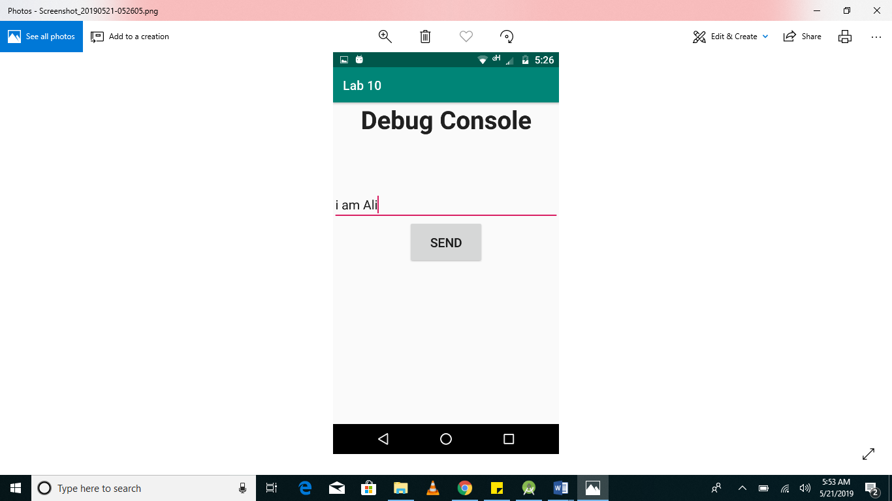

**Task 02:**

**Activity_main.xml:**

*<?*xml version="1.0" encoding="utf-8"*?>*<RelativeLayout xmlns:android="http://schemas.android.com/apk/res/android"  
  
 xmlns:tools="http://schemas.android.com/tools"  
 android:layout_width="match_parent"  
 android:layout_height="match_parent"  
 tools:context=".MainActivity">  
  
 <LinearLayout  
 android:layout_width="match_parent"  
 android:layout_height="match_parent"  
 android:weightSum="10"  
 android:orientation="vertical">  
  
  
  
 <TextView  
 android:id="@+id/title_text_view"  
 android:layout_width="match_parent"  
 android:layout_height="wrap_content"  
 android:text="Debug Console"  
 android:textSize="40dp"  
 android:textAppearance="?android:textAppearanceLarge"  
 android:textStyle="bold"  
 android:textAlignment="center"/>  
  
 <TextView  
 android:layout_width="match_parent"  
 android:layout_height="wrap_content"  
 />  
  
  
  
 <TextView  
 android:id="@+id/console"  
 android:layout_width="match_parent"  
 android:layout_height="match_parent"  
 android:textSize="20dp"  
 android:textAppearance="?android:textAppearanceLarge"  
 android:textStyle="bold"  
 android:background="@color/colorBlue"  
 android:textColor="@color/colorBlack"  
 />  
  
  
  
 </LinearLayout>  
  
</RelativeLayout>

**BroadcastReceiver.java:**

package com.example.lab 10;  
  
import android.content.BroadcastReceiver;  
import android.content.Context;  
import android.content.Intent;  
import android.widget.Toast;  
  
public class ReceiverBroadcast extends BroadcastReceiver {  
  
 public ReceiverBroadcast(){  
  
 }  
  
 @Override  
 public void onReceive(Context context, Intent intent) {  
 Toast.makeText(context,"Broadcast Received!",Toast.LENGTH_SHORT).show();  
 }  
}

**Output:**

